Making a Thermometer:
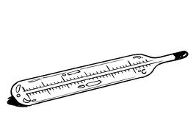
Materials: water, rubbing alcohol, clear, narrow-necked plastic bottle, food coloring, clear plastic, drinking straw, modeling clay
1) Pour Equal parts of tap water and rubbing alcohol into the bottle, filling about 1/8 to a ¼ of the bottle.
2) Add a couple of drops of food coloring and mix.
3) Put the straw in the bottle, but don’t let the straw touch the bottom. (DO NOT DRINK THE MIXTURE.)
4) Use the modeling clay to seal the neck of the bottle, so the straw stay in place.
5) Now hold your hands on the bottle and watch what happens to the mixture in the bottle.

